MACHINE LEARNING INTERNSHIP W/
ANALYST LAB AFRICA
________________________________________________________________
WEEK 8 REPORT: CAPSTONE PROJECT
By Ibinabo Direh

For my capstone project I have chosen to improve on the previous work done on the Pima Indians Diabetes dataset due to time constraints.

PROBLEM STATEMENT
Diabetes often goes undetected until symptos are advanced, particularly in places with limited access to healthcare or routine screening. This project builds a classification model that uses 8 basic health measurements (already commonly collected) to flag patients at elevated risk of diabetes, so that they can be prioritised for further confirmation.
This matters because flagging risk early is cheaper and faster compared to full diagnostic check-ups. It can help guide the usage of limited resources to those who most likely need it. The tool is to aid, not replace medical judgement.

DATASET
Pima Indians Diabetes Dataset.
768 records, 8 features, binary target, Outcome (0 = non-diabetic, 1 = diabetic).

DATA PREPROCESSING
Zeros in Glucose, BloodPressure, SkinThickness, Insulin and BMI were treated as missing values.
Glucose and BloodPressure were imputed with mean as they had a skew value less than 0.5.
SkinThickness, Insulin and BMI were imputed with median. (Skew > 0.5)
Features were scaled using StandardScalar to make sure no values unevenly weigh on the model, and fit on the training set only to avoid data leakage.

EDA OBSERVATIONS
- Glucose shows the highest linear correlation to the target variable, Outcome while BloodPressure shows the weakest linear correlation to the outcome (surprisingly). This only shows linear correlation. Blood Pressure actually has high relationship with the diabetes in patients, but this reflects indirectly through other factors.

- Correlation heatmap reveals a high correlation between pregnancies and age (0.54) which makes sense naturally. The same correlation value applies to SkinThickness and BMI.

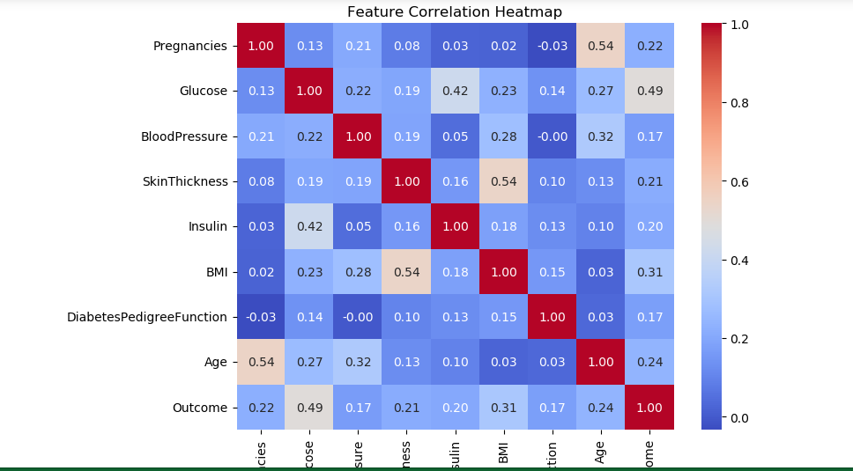

- The boxplots confirm the discoveries above between Glucose, BloodPressure and Outcome.
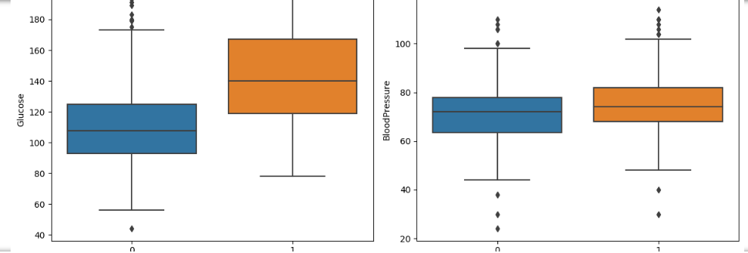

ALGORITHM USED: Logistic Regression.
Logistic Regression was selected due to its strong performance on this dataset (an ROC-AUC of 0.82 and an Accuracy of 0.75 was achieved.) and interpretability. It also has less risk for overfitting on a small dataset as this compared to the more complex models.

MODEL EVALUATION
Metric | Baseline | Tuned (Scaled)
Accuracy | 0.7532 | 0.7532
Precision | 0.6667 | 0.6667
Recall | 0.6182 | 0.6182
F1 | 0.6415 | 0.6415
ROC-AUC | 0.8211 | 0.8231

GridSearchCV (5-fold, c=[0.01, 0.1,1,10,100])
C = 1 (which is the default) was confirmed as optimal. There was therefore no improvement from tuning.
There was some improvement in ROC-AUC score which can be attributed to feature scaling rather than hyperparameter tuning.

DEPLOYMENT
The model was deployed using a FastAPI RESTAPI, served by Uvicorn. The API displays a POST/predict entry point receiving the 8 input features and returning the binary outcome as prediction. The model and scaler were saved using joblib and loaded at server startup.

LIMITATION
- Insulin required imputation for about 49% of records. This influenced Interquartile range and reduces reliability of prediction for patients with unusual insulin levels.
- The model’s performance (75% accuracy) means that roughly 1 in every 4 predictions will be wrong. H

RECOMMENDATIONS
- Glucose, BMI and Age should be prioritised when full screening options are limited.
- Model output should only be treated as a signal for priority in case of limited time/resources, not as an absolute diagnosis.
- Future work should explore other models like Random Forest and XGBoost. They may be able to capture non-linear correlations that Logistic Regression missed.
CONCLUSION
This project demonstrated a complete machine learning workflow, from problem definition to deployment using the Pima Indians Diabetes dataset and Logistic Regression model which achieved a 75% prediction accuracy. The model was successfully deployed as a working API capable of returning real-time predictions given new patient data.

